Personal Website: Final Development Report
Website Link: https://www.fmorafa.com
Hosting Platform: IONOS.com
Github Link: fmorafa/personal-portfolio: Personal website and domain

1. Updated Site Map
Since the midterm submission, the website has expanded and been reorganized to improve navigation, user experience, and content clarity. The updated structure now includes:
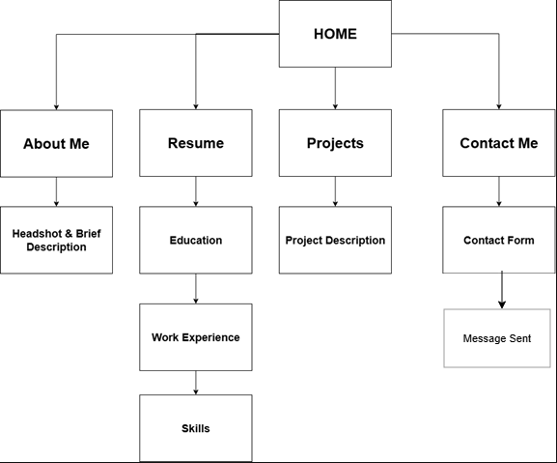

Current Pages
- Home – Updated landing page with improved headshot framing, refined color scheme, responsive design, and fade-in animations across content.
- About Me – Revised structure, indentation cleanup, and styling to match the modernized theme.
- Resume (Dynamic) – Database-driven content using PHP and MySQL, with significantly improved readability and mobile formatting.
- Projects – Now includes dynamic client-side filtering using JavaScript, improved layout, and consistent visual styling.
- Contact – PHP-based contact form with validation and email functionality.
- Message Sent – Confirmation page displayed after submitting the contact form.

Removed Pages
- resume.html – Removed after merging all resume content into the dynamic PHP version.
Navigation has been standardized across the site, improving accessibility and consistency.

2. Hosting Research and Choice
During the initial development phase, several hosting platforms were evaluated, including GitHub Pages, Netlify, and IONOS. Because the website required server-side scripting and database integration, platforms without PHP/MySQL support were eliminated.
Reasons for Choosing IONOS
- Complete PHP support for backend logic.
- Support for MySQL/MariaDB databases.
- Straightforward domain configuration.
- Reliable hosting performance and uptime.
- Easy-to-use file manager for uploading updates quickly.

Additional Consideration
While IONOS is excellent for PHP deployment, it is less flexible for modern JavaScript frameworks like React. This influenced the decision to consider switching hosts if the website transitions to a full React architecture in the future.
However, for the purposes of this project, IONOS effectively supported all necessary backend functionality.

3. Explanation of Technologies Used
This project integrates a full suite of frontend and backend technologies, each selected to demonstrate practical web development skills while maintaining full control over the codebase without external frameworks.

HTML5 – Structure and Semantics
HTML5 provides the foundational structure of the website. Semantic elements such as <header>, <nav>, <section>, and <footer> were used throughout to create clean organization and improve accessibility and SEO. Each page relies on clear document hierarchy to enhance readability and maintainability. Structured sections make pages like About Me and Projects easy to expand or update.

CSS3 – Styling, Layout, and Responsiveness
CSS3 defines the website’s visual identity, including its blue-and-white color scheme, typography choices, and spacing adjustments. Flexbox and Grid were heavily utilized to build layouts that scale smoothly across phones, tablets, and desktops.
A major improvement included refactoring table styling out of individual pages into style.css, ensuring uniformity and cleaner code.
Global fade-in animations were introduced using CSS keyframes to make page transitions more professional and visually appealing while remaining accessibility-friendly.

JavaScript – Interactivity and Dynamic Behavior
JavaScript powers all dynamic client-side features.
The most notable addition is dynamic project filtering, allowing users to select a category and instantly filter visible projects without reloading the page.
JavaScript also contributes to UI enhancements across the site, including:
- Navigation interactions
- Smooth animations
- Responsive adjustments
- Button and link effects
The JavaScript codebase was cleaned and restructured to improve maintainability and flexibility for future additions.

PHP – Backend Logic, Validation, and Data Access
PHP is used extensively for server-side processing. It handles:
- Retrieving data from the MySQL database for the Resume page
- Validating the contact form
- Sending emails securely
- Redirecting the user to the Message Sent confirmation page
PHP allowed the Resume page to transition from a static HTML file to a dynamic, maintainable interface that updates automatically when the database contents change.

MySQL/MariaDB – Database Integration
A MySQL database stores the resume information, including skills, experience, and education. The Resume page retrieves this data using PHP queries and formats it into responsive tables.
This integration demonstrates the use of relational databases in a real deployment environment and keeps long-term content sustainable without manual HTML edits.

Python – Development and Automation Support
Python was used during development for tasks such as:
- Data formatting for resume entries
- Testing and validating data structures
- Pre-deployment automation tasks
Although Python is not used in the deployed site, it directly contributed to backend preparation and workflow efficiency.

Tables and Structured Data
Tables are primarily used on the Resume page, now more readable and responsive after extensive refactoring. CSS improvements ensure tables are accessible, mobile-friendly, and visually consistent.

Form Validation
Form validation is a combination of HTML5 client-side rules and PHP server-side checks. This ensures user messages are correctly formatted, sanitized, and securely submitted to the intended email address.

4. Resources Used
Development Tools
- Visual Studio Code – Primary coding environment.
- Git & GitHub – Version control, tracking revisions, and backup.

Generative AI
- Used primarily for minor debugging, PHP mail setup verification, and a few syntax corrections. Also was integral in making sure formatting was handled correctly for larger changes to styles.css and double checking form safety measures.
Reference Materials
- MDN Web Docs for HTML/CSS/JS standards
- PHP and MySQL documentation
- Hosting documentation from IONOS

Personalization
- Updated blue-and-white theme aligned with personal branding
- Improved headshot framing and landing page layout
- Personalized projects with dynamic filtering
- Responsive and accessible table structures
- Cleaned code indentation and formatting across all pages

5. Accessibility Report
An accessibility review was run against the final deployment using an online audit tool.
Results
- Score: 10/10 on every page, including Message Sent
- Verified standards:
  - Sufficient color contrast
  - Semantic headings
  - Form labels and ARIA attributes
  - Keyboard navigability
  - Proper alt text for all images
  - No inaccessible animations
The site meets WCAG guidelines and ensures a usable experience for all visitors.

6. Major Adjustments Since Midterm
Since the midterm update, the following enhancements were implemented:

Visual and Structural Improvements
- Updated color palette
- Improved typography and spacing
- Extensive mobile-responsive refinements
- Fade-in Animations added to all main pages

Backend and Content Upgrades
- Resume moved fully to dynamic PHP
- Database-driven tables cleaned and centered
- Project filtering system implemented in JavaScript
- Contact form added and improved upon with more robust validation

Codebase Refinement
- Consolidated CSS files and extracted table styling
- Cleanup of About Me indentation and structure
- Removal of unused pages such as resume.html
- Animation and layout utilities centralized

7. Future Plans
Now that many of the original goals have been completed, the following updated plans remain:

Short-Term Plans
- Add GitHub repository links for each project
- Continue improving website performance
- Add subtle micro-interactions (nonessential animations)

Long-Term Plans
- Convert the entire site into a React application to expand component-based development skills
- Move to a more React-friendly hosting environment (e.g., Vercel or Netlify)

8. Reflection
Building the final version of this website was an in-depth learning experience that strengthened both my frontend and backend development skills. I improved at writing clean semantic HTML, designing responsive layouts with CSS, and implementing client-side interactions with JavaScript.
On the backend, I gained practical experience integrating PHP with a MySQL/MariaDB database, validating form submissions, and deploying a functioning full-stack web application.

This project represents my growth as a developer and is a tangible, accessible, and personalized online presentation that I can continue to improve as my skills expand. I’m incredibly proud of the experience I’ve gained from this and it serves to give me more confidence to challenge myself in the future and build from here.

